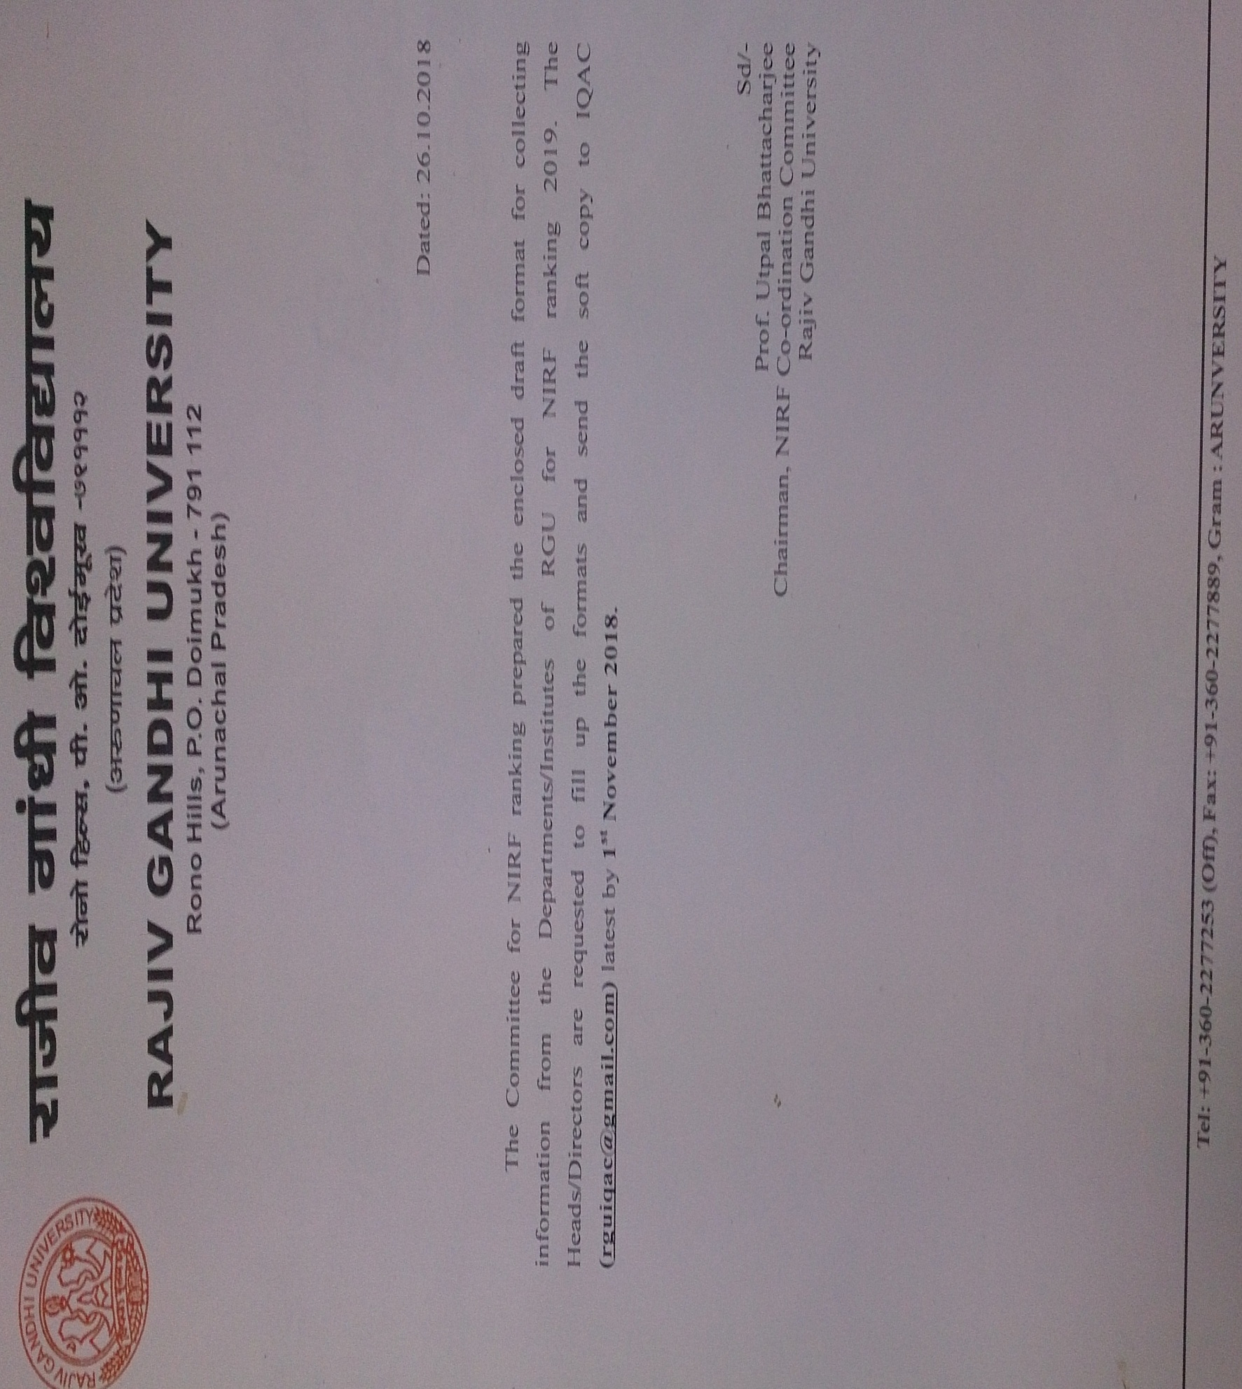

URGENT
Detail Information Required from the Departments/Institutes For NIRF Ranking, 2019
1. Course-wise student details of the Department
Courses | Sanctioned intake for the year 2017-18 (Previous year only) | Number of students admitted (Actual Strength) | Break-up of the student on gender |  | Break-up of the students based on domicile |  | Break-up of the students based on socio-economic status
 |  |  | Male | Female | From the state | From outside state | Socially challenged | Economically Challenged (not included in socially challenged category)
PG Diploma/Certificate Course (1 year duration)
PG (2 years duration)
PG (3 years duration)
UG (3 years duration)
UG (4 years duration)

2. Ph.D. Students Details
(Students who are perusing Ph.D. in the department admitted on or before academic year 2017-18 (previous academic year) should be included. Students admitted in the year 2018-19 need not required to the included.
Full-time (Number only) | Part-time (Number only) | Total

3. Placement and Higher Education Details (Fill-up the sub-sections which are applicable)

  - PG Diploma/Certificate course (1 year duration)
Programme Name | Students intake in the year 2016-17 | No of students graduated in stipulated time  (Year 2017-18) | Number of students placed | Median Salary | Number of Students selected for Higher studies

3.2 PG (2 years duration)
Programme Name | Students intake in the year 2015-16 | Lateral Entry (if any) in the year 2016-17 | No of students graduated in stipulated time  (Year 2017-18) | Number of students placed | Median Salary | Number of Students selected for Higher studies

3.3 PG (3 years duration)
Programme Name | Students intake in the year 2014-15 | Lateral Entry (if any) in the year 2015-16 | No of students graduated in stipulated time  (Year 2017-18) | Number of students placed | Median Salary | Number of Students selected for Higher studies

  - UG (3 years duration)
Programme Name | Students intake in the year 2014-15 | Lateral Entry (if any) in the year 2015-16 | No of students graduated in stipulated time  (Year 2017-18) | Number of students placed | Median Salary | Number of Students selected for Higher studies

  - UG (4 years duration)
Programme Name | Students intake in the year 2013-14 | Lateral Entry (if any) in the year 2014-15 | No of students graduated in stipulated time  (Year 2017-18) | Number of students placed | Median Salary | Number of Students selected for Higher studies

4. IPR
Activity | Year (Number only)
 | 2017 | 2018
Patent Published
Patent Granted

5. Any highly reputed national/international award/recognition from the central government agencies received by the faculty members in the year 2017-18 (give details):

1.

2.

3.

4.

